Grade Calculator Code: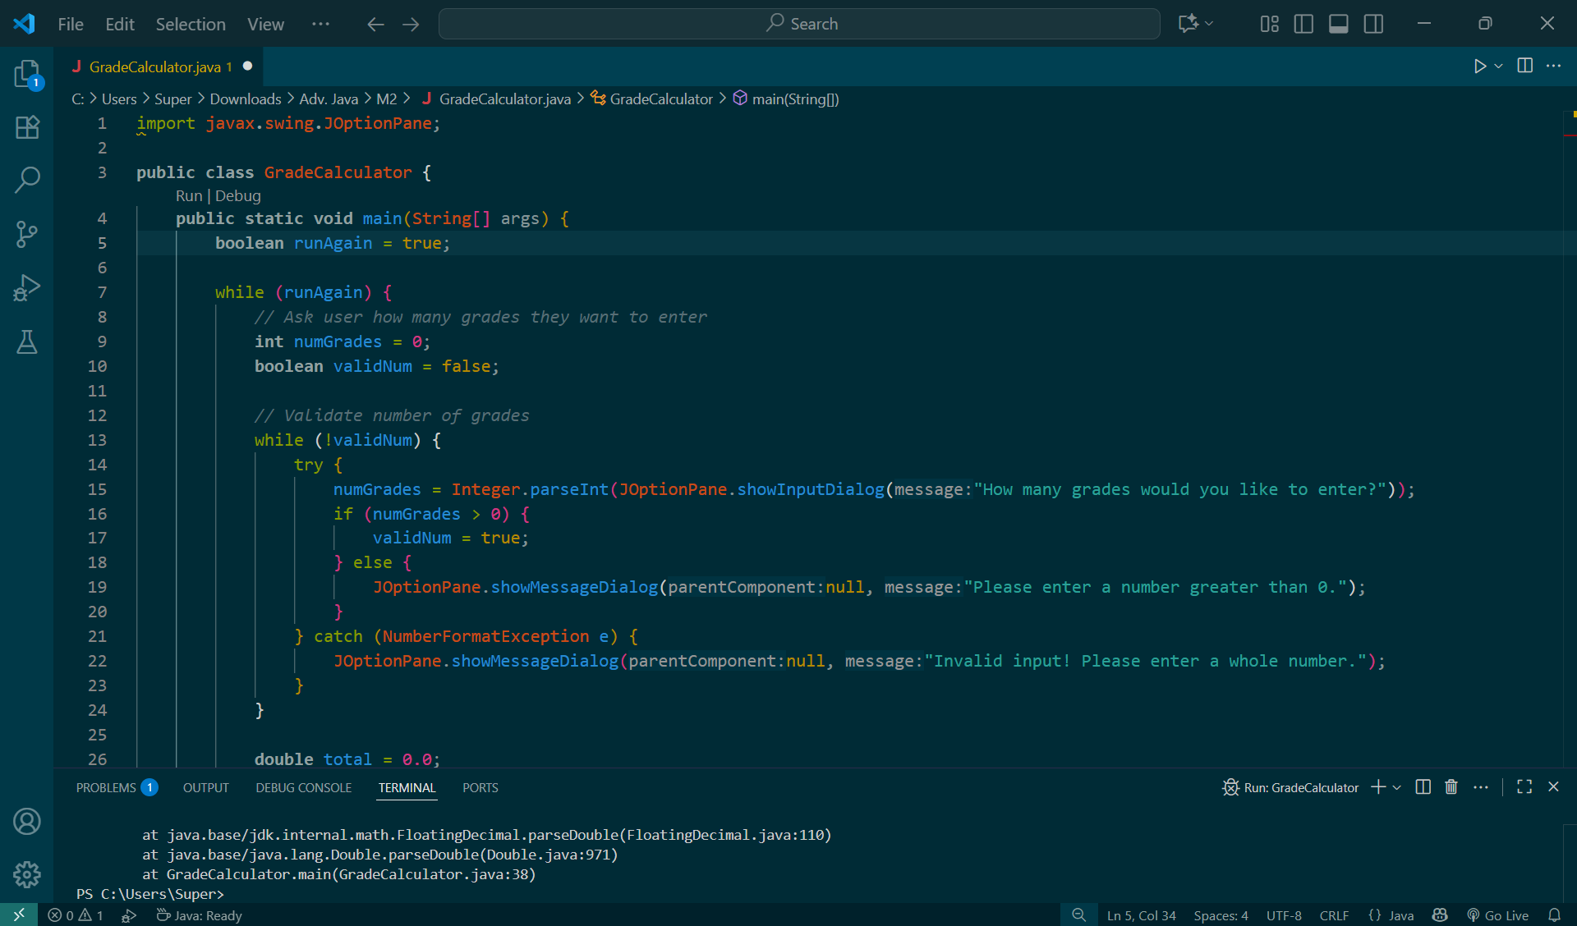

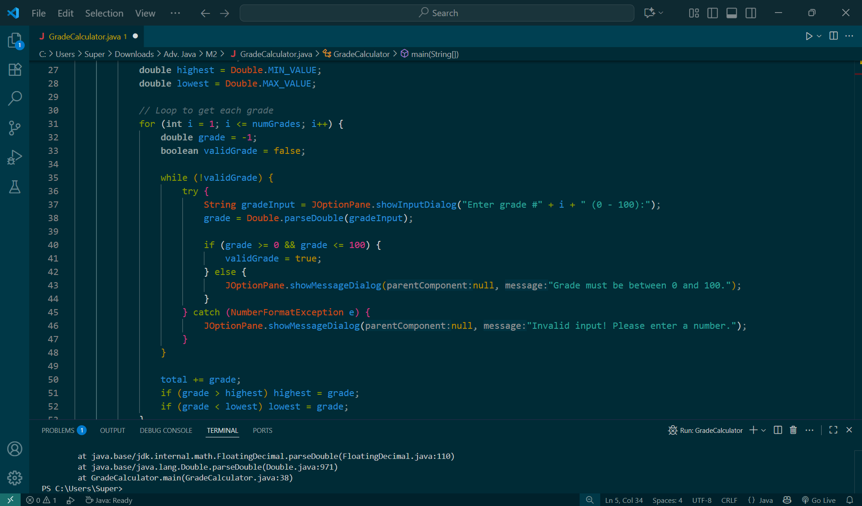

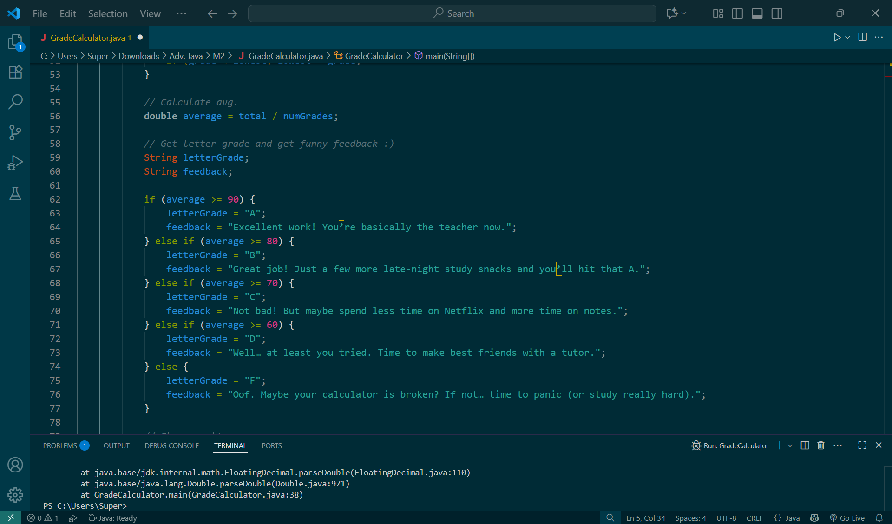

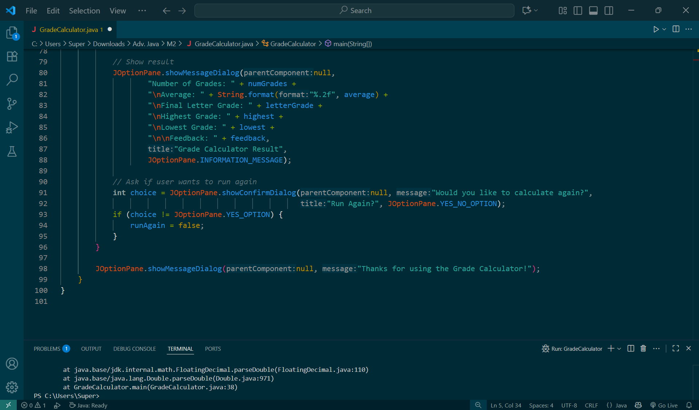

Grade Calculator Code Output:



